COVER LETTER

Dear Sir/Madame,
From the first day I began managing track sector projects, I have consistently realized my objective of bringing every single project in on time and under budget.
To help you learn more about my track record, I have enclosed my resume. While it illustrates my experience and training, what it cannot communicate is my dedication to my work. My professional creed includes:
- Pride in the quality of my work, and a willingness to personally perform even the most menial tasks to remove project obstacles and get the job done.
- Ability to site inspects which includes formation handover, spacing and squaring of sleepers' inspection, track geometries, CPO and repair inspection.
- Expertise inall type or gauges for track works, for example, track gauge for taking track parameters readings, turnout installations, temperature reading for distressing track and welding temperature.
- Skilled in concreting materials and inspection, for example, slum test, load test, stressing test and concrete cube test.
- Excellent skills in guiding, motivating, training and mentoring other workers.
Based on my experience and strong commitment to my work, I know I will add significant value to your team. I look forward to discussing my capabilities in more detail, and am available for a personal interview at your convenience

Thank you for your time and consideration.

Sincerely,
Sutharsan Yogarayan

RESUME
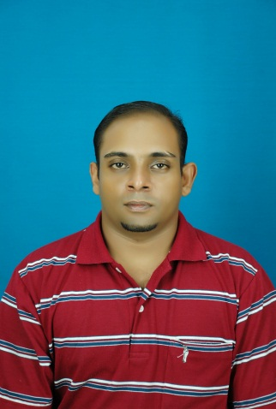

PERSONAL INFORMATION

NAME | : | Sutharsan A/L Yogarayan
ADDRESS | : | No. 23, Jalan Perlis Canning Garden31400Ipoh Perak
GENDER | : | Male
D.O.B | : | 28-07-1982
NIRC | : | 820728-08-6139
CONTACT NUMBER | : | 017-3800753
E-MAIL ADDRESS | : | sudhan_82@hotmail.com
MARITAL STATUS | : | Single
NATIONALITY | : | Malaysian
RACE | : | Indian
RELIGION | : | Hindu

EDUCATION

School / University | Graduation Date | Highest Qualification | Grades
Kojel Damansara Utama | 2003 | Engineering | -
Kolej Damansara Utama (KDU) | 2000 | Pre-U | Pass
Sek.Men.St.Micheal | 1999 | SPM | Pass

EMPLOYMENT HISTORY

Year | Employer | Position | Description / Responsibilities
2011-2013 | Leighton Contractors | QA/QC | - Sleepers Factory ACPI – Slum test, Load test, Stressing, Outer to Outer Gauge inspection, Production & Delivery Report.  - Sleeper Factory Mastrak – Slum test, load test, Outer to Outer Gauge Inspection, Production & Delivery Report.  - Site Inspection - Formation Handover, Spacing/Squaring of sleepers' inspection, Track Geometries, CPO, Repair inspection.
2005 - 2008 | Asas Bali Sdn Bhd | Supervisor | Roadworks Landscaping
2003 - 2005 | Shell Malaysia | Subsidy Department Executive | Diesel subsidy approval with private companies and government sectors vehicles

PERSONAL ATTITUDE

- Fast learner, creative, analytical, determined
- Adapt well to pressures and changes at workplace
- Excellent inter-personal skills
- Very experienced in relationship forming with peoples of either foreign or local origin
- Strong organizational and leadership skills
- Independent and good team player
- Avid learner and very adaptable to changing environments
- Self-motivated, execution-focused and result oriented
- Ambitious and hardworking committed to excellence

TECHNICAL SKILLS
- Well verse on using all type or gauges for track works
Example: Track gauge for taking track parameters readings, turnout installations, temperature reading for distressing track and welding temperature.
- Experience in concreting materials, inspection
Example: Slum test, load test, stressing test, concrete cube test.
PERSONAL SKILLS AND ABILITIES:

- Communication Skill
Language | Written Proficiency | Spoken Proficiency
English | Very good | Very good
Bahasa Melayu | Very good | Very good
Tamil | Fairly good | Very good

- Computer Skill
- Microsoft Office (Word, PowerPoint, Excel and Publisher)
- Macromedia Flash
- Basic Internet Knowledge

CO-CURRICULAR ACTIVITES

Badminton / 1997 -1999
(State Level)
Badminton
State Level 1997 - 1999
Represented Kolej Damansara Utama (KDU)
(Collage Level)
BadmintonAcademy (NSBA)

PERSONAL INTERESTS:
- Exploring new places
- Photography
- Playing badminton
- Playing golf

Expectable Salary: RM 4000

Availability: Anytime

REFEREES:

- Kaliesvaran a/l Veerapan
Recovery Manager Leington EDTP Project Ipoh - Padang Besar
Leington EDTP Project Ipoh - Padang Besar
Phone: 0122019785

2. Arvindran
Section Head QA/QC
MMC GAMUDA EDTP Ipoh - Padang Besar
Phone: 0125016454

- Azrin Mesni
QAQc Engineer Leington EDTP Project Ipoh - Padang Besar
Phone: 0163960885

